SportFish

Product Specif**ication**

## Revision History

This is a fictional product specification for reference purposes only. The content is not correct. It is designed to show organization.

| **Date** | **Version** | **Description** | **Author** |
| --- | --- | --- | --- |
| December 10, 2012 | 0.5 | First Draft | Dave Parker |
| August 4, 2013 | 0.75 | Second Draft | Adeo Ressi |
|  |  |  |  |

# 

# Abstract

The specification describes the SportFish iOS App and website.

# Overview

SportFish is a smartphone app with many of the features of more expensive marine electronics, e.g. gps and weather. It also combines other external data sources including state fishing rules books (Washington State 136 pages), tides, weather, etc.

The app allows you to know if you are fishing in an approved area at the specific date and time of your request via GPS data, or if you drifted into an area that you can not fish, based on time, day, Latitude and Longitude. The app allows customers to mark a one click catch for results, time, date, location, weather and tide; upload photos of their catch, share via social media and annotate their results. This data can then be plotted over time via the mobile app or website to provide better predictive data.

The product build is divided into three phases. Phase one is more a prototyping with basic functions to prove the Customer use cases on iOS. Phase two is to build on Android and Windows Mobile. Phase three features (marked with an “*”) are more advanced or web features to be built into the system to achieve both the completeness in service provide and the scalability.

# 

# 

# Terminology

The following terminology is used in the development of SportFish.

## Catch Record Card

Is a state tool for estimating the catch of specific fish species, see WDFW.

## Catch Record Codes

Are the code designation for specific species as set by the State fish and wildlife

## Customer

An individual smartphone user with basic phone, address, and location data.

## Emergency Rule Changes

Are notifications by changes that aren’t otherwise captured in the pamphlet.

## Fishing Times

Are the times and dates that are allowed in the state regulations.

## Fishing Locations

Are the specific location based regulations and constraints on locations.

## GPS

Global Positions System is the connection to the smartphone.

## GPS Integration

Is the method of connecting GPS data to specific smartphone operating systems

## News Updates

Is the ability to push specific state updates, rules changes or notifications via email or text message.

## Photos/Video

Is the feature on smartphones that allows users to take and upload photos.

## Social Media Credentials

The credentials users used to login to other social media sites, such as Facebook, Twitter, linkedin, etc. These credentials usually are user names and passwords.

## Social Media Promotion

A non-conventional promotion channel via social media sites with the viral effects.

## State Rules

Are the rules outlined in specific State Fish & Wildlife pamphlets, specifically starting with Washington State - http://wdfw.wa.gov.

## Text Messages

Is the feature allowing mobile phones to receive short messages SMS or text messages via a wireless network.

## Tides Data

Is accessing the public available data.

## Weather

Is the ability for a smartphone to pull weather data from an available API.

# 

# 

# Customer Definition

An estimated 44.4 million Americans ages 7 and older fish. One out of every six U.S. residents 16 and older fish. 25 percent of U.S. males fish, and 8 percent of U.S. females fish. SportFish will focus on older and more successful fishermen.

## Demographics

Gender: **Male**

Average Age: **45 Years Old**

Household Income: **$150,000 per Year**

Marital Status: **Married with Older Children**

## Ideal Customer

The ideal customer of SportFish is John. John knew at a young age he was going to be a fisherman. He started fishing on the East Coast with his grandfather. Not only did John love being out on the ocean, but he never got seasick: it was in his blood. John has been fishing for 25 years, and he owns two boats specifically for fishing. John has two children, and they both fish. John fishes because it makes him happy.

# 

# 

# Product Roadmap

|  | **1** | **2** | **3** | **4** | **5** |
| --- | --- | --- | --- | --- | --- |
|  | **User Registration** | **Content Creation** | **Administration** | **Advertising** | **Social Media** |
| **1** | Feature 1 (MVP) | Feature 1 (MVP) | Feature 1 (MVP) | Feature 1 (Beta) | Feature 1 (Beta) |
| **2** | Feature 2 (MVP) | Feature 2 (MVP) | Feature 2 (Beta) | Feature 2 (Beta) | Feature 2 |
| **3** | Feature 3 (MVP) | Feature 3 (Beta) | Feature 3 (Beta) | Feature 3 | Feature 3 |
| **4** | Feature 4 (Beta) | Feature 4 (Beta) | Feature 4 (Beta) | Feature 4 | Feature 4 |
| **5** | Feature 5 (Beta) | Feature 5 | Feature 5 | Feature 5 | Feature 5 |
| **6** | Feature 6 | Feature 6 | Feature 6 | Feature 6 |  |
| **7** | Feature 7 | Feature 7 |  | Feature 7 |  |
| **8** |  | Feature 8 |  | Feature 8 |  |
| **9** |  | Feature 9 |  |  |  |
| **10** |  | Feature 10 |  |  |  |

# 

# 

# 

# Product Features

At the center of user experience is the mobile app used for knowing location and approval of fish/no fish.

## Registration

* Minimum data required – see below
* Approval of Terms and conditions
* Mobile text message approval

### Required Data Field

* Name
* Email
* Address
* City, ST, Zip
* Phone
* Text Message Y/N

### Optional Data Fields

* Fishing License Number
* Carrier
* Fishing License number
* Date Info
* GPS Data
* Species
* Notes field

## Fish/No Fish

At the beginning, the fisherman should know if they can fish, species, quota, length and measurement requirements

## Tagging a Catch

The customer must be able to click a “Catch” button that will note, the date, time and specific GPS location

## Posting to Social Media

The customer must be able to post a photo of the catch, with the option

## Commenting

The customer must have the ability to note specific details of the catch, this will include, depth, bait, and free form text fields.

## Pamphlet Resources

Is the process of bringing various tools from the PDF pamphlet onto the smartphone

* Species recognition – images
* Rules
* Catch reporting

## Commerce

### Commerce Engine (Phase 2)

There is no shopping cart planned for this time.

### Checkout with Google

There is no shopping cart planned for this time.

## Reports

The following reports need to be generated, either as an on-demand click, or as a periodic routine.

* Fishing time
* Results

## Dashboard

This is where a logged in Customer can centrally view and manage their Customer information, history activities, track social media updates, generate and view various reports and analyses. At the minimum, dashboard must include:

* Account management
* Social media credential management
* History

## Outside Data Sources available via API

Washington Department of Fish and Wildlife doesn’t currently have an API. There is an RSS Feed for rules updates. These will need to be manually tracked and updated in the database

* GPS
* Tides

# 

# 

# Product Workflows

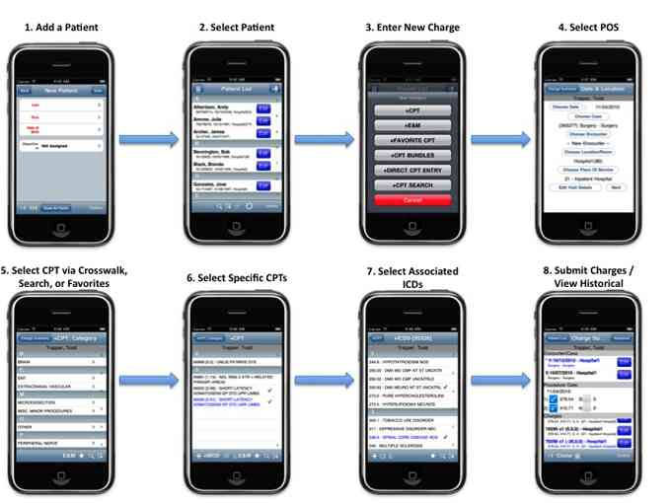

# 

# 

# Product Screenshots

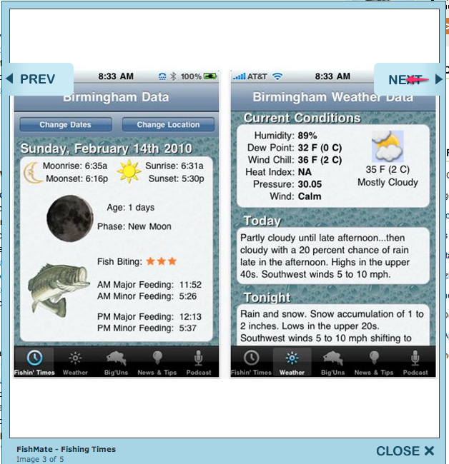

# 

# 

# Product Development

Phase 1 of the product development will focus on creating a minimal viable product, the MVP. There will be a basic Website and Mobile App, described below.

## Website

At launch, the website will provide information directing the customer to the App Store to download the App. In Phase two (Phase 2) the website will provide additional functionality the parallels the mobile app.

## Mobile App

At launch, the Mobile App will be the primary offering. It will contain the following features:

* Login
* Social Sharing
* Reports
* Customer Profiles

# 

# 

# Estimation

# 

# 

# Questions

## Is there room for a new market entrant?

Yes. Lorem ipsum dolor sit amet, consectetur adipisicing elit, sed do eiusmod tempor incididunt ut labore et dolore magna aliqua. Ut enim ad minim veniam, quis nostrud exercitation ullamco laboris nisi ut aliquip ex ea commodo consequat. Duis aute irure dolor in reprehenderit in voluptate velit esse cillum dolore eu fugiat nulla pariatur. Excepteur sint occaecat cupidatat non proident, sunt in culpa qui officia deserunt mollit anim id est laborum.

## How will SportFish differentiate itself?

This is how. Lorem ipsum dolor sit amet, consectetur adipisicing elit, sed do eiusmod tempor incididunt ut labore et dolore magna aliqua. Ut enim ad minim veniam, quis nostrud exercitation ullamco laboris nisi ut aliquip ex ea commodo consequat. Duis aute irure dolor in reprehenderit in voluptate velit esse cillum dolore eu fugiat nulla pariatur. Excepteur sint occaecat cupidatat non proident, sunt in culpa qui officia deserunt mollit anim id est laborum.

# Competition

There are at least a dozen competitive apps in the iOS app store and a dozen more on Android. The top three are below:

## Competitor 1

<http://www.competitor1.com>

Lorem ipsum dolor sit amet, consectetur adipisicing elit, sed do eiusmod tempor incididunt ut labore et dolore magna aliqua.

## Competitor 2

[http://www.competitor2.com](http://www.competitor1.com)

Lorem ipsum dolor sit amet, consectetur adipisicing elit, sed do eiusmod tempor incididunt ut labore et dolore magna aliqua.

## Competitor 3

[http://www.competitor3.com](http://www.competitor1.com)

Lorem ipsum dolor sit amet, consectetur adipisicing elit, sed do eiusmod tempor incididunt ut labore et dolore magna aliqua.